Math 352 :Task 2

Mustafa Mahmoud Abdelaziz

2227263

Introduction
This report presents a comparison of various numerical methods for solving the ordinary differential equation (ODE):
- Forward Euler Method
- Modified Euler Method
- Backward Euler Method
- Runge-Kutta Methods (2nd, 3rd, and 4th order)
- Adams-Bashforth 2-step Method
- Adams-Moulton 2-step Method

MATLAB Implementation
Numerical Solution of ODE using Forward Euler, Modified Euler, and Backward Euler methods
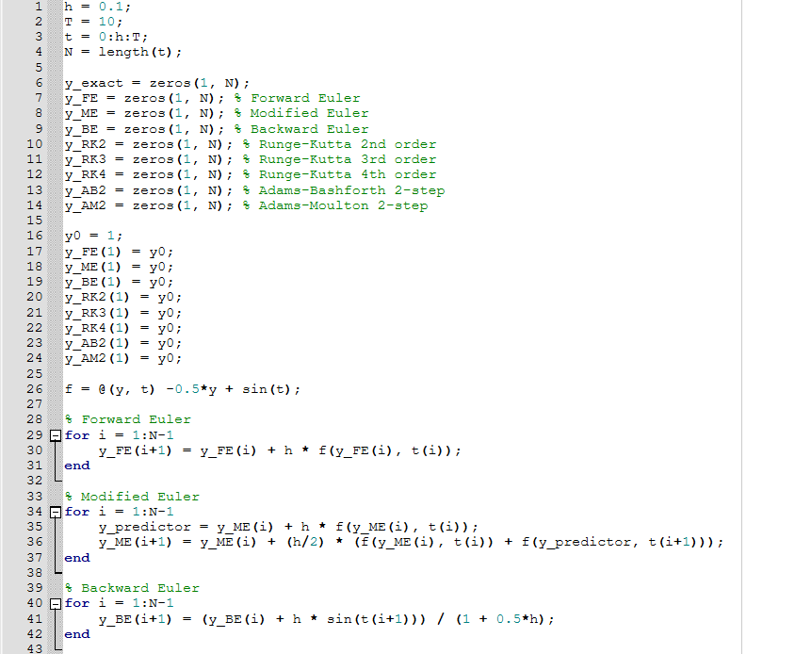

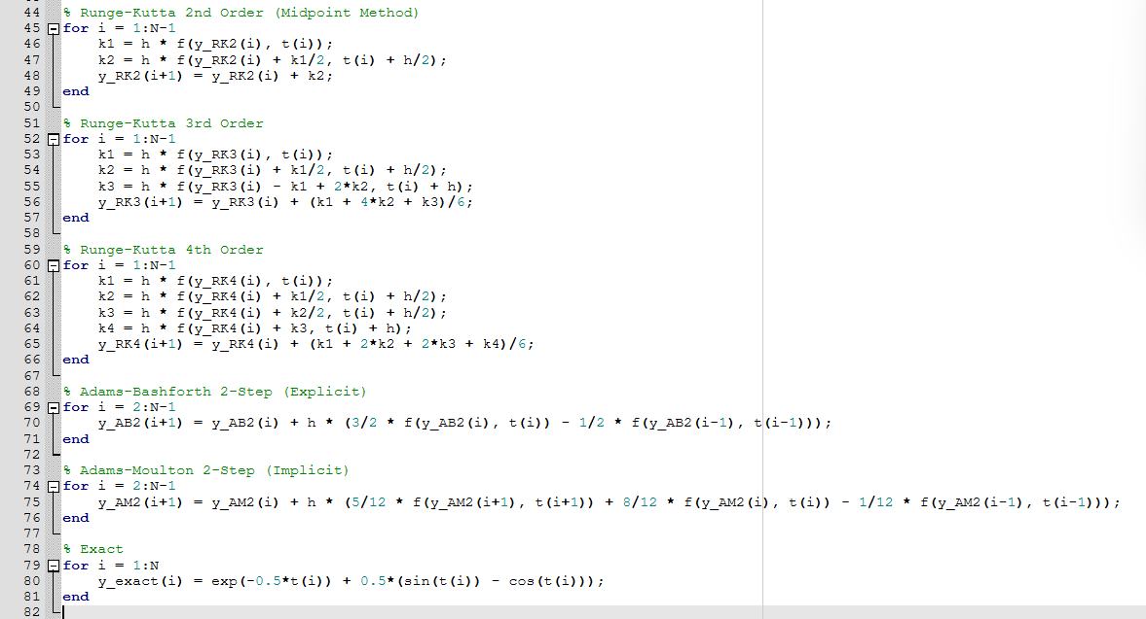
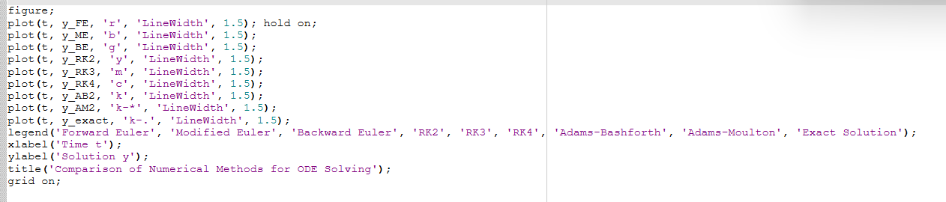
results
The numerical solutions obtained using each method are plotted alongside the exact solution. The plot allows for a visual comparison of accuracy and stability.
Observations
- The Forward Euler Method exhibits significant error and divergence over time due to its low accuracy and explicit nature.
- The Modified Euler Method shows better accuracy compared to Forward Euler, as expected.
- The Backward Euler Method is more stable but tends to be slightly less accurate for small step sizes.
- The Runge-Kutta Methods (especially 4th order) demonstrate high accuracy and stability.
- The Adams-Bashforth Method provides a reasonable approximation but can introduce oscillations.
- The Adams-Moulton Method balances stability and accuracy, showing a tighter fit to the exact solution.
Conclusion
The 4th-order Runge-Kutta method provides the best balance of accuracy and computational cost. Implicit methods like Backward Euler and Adams-Moulton offer stability but require solving equations iteratively. Explicit methods like Forward Euler are simple but less reliable for stiff equations.
Further experimentation with smaller step sizes or adaptive step size techniques could yield even more precise solutions.

